Name:
Address:
Postcode:
Tel:
Email:
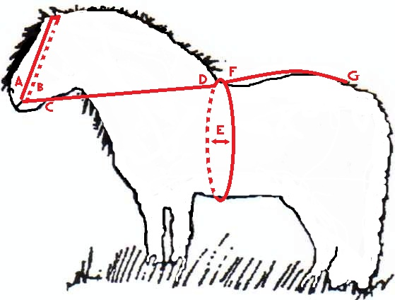
Order Date: | Delivery Date – Please allow 4 weeks for Delivery

Items Required:

Special Instructions:
Measurements
Saddle Pad
Colour: Size:
Girth: Measure all the way around the pony, E on the diagram (inch/cms) Colour:
Stirrup Leathers: Riders inside leg measurement (inch/cms) Colour:
Side Reins: Measure C to D on the diagram (inch/cms)

Crupper: Measure F to G on the diagram (inch/cms)
Pony Height |  | Breed |  | Age (if under 6)

Bridle
Overhead, diagram A to B |  | Browband
Crown (just wide part of headpiece) |  | Throat (from approx. 1.5” below ears)
Nose (all the way around) |  | Reins, diagram C to D

Delivery Address if different from above, (delivery will need to be signed for).

Complete form and email to: zoesnape@ymail.com

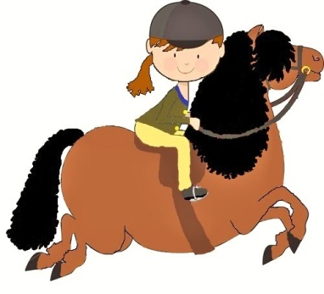
www.shetlandshowingtack.com
Tel: 07949 125195

